**Team 1 - Addition**

1. **Game Slide - Addition**

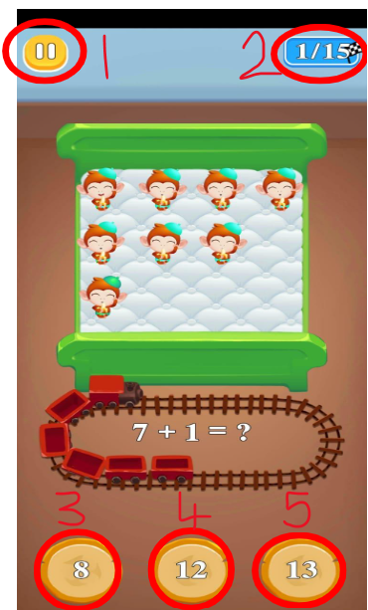

1.1 **InvokeGamePauseButton**

1.1.1 When clicked an audio event is played

1.1.2 The “Pause Menu” scene function is invoked

1.2 **QuestionsCounter**

1.2.1 Displays current number of correct answers, target goal of answers

1.3 **InvokeAnswerSelectionA-Button**

1.3.1 When clicked an audio event is played

1.3.2 If correct answer, “Game Slide - Correct” scene function is invoked

1.3.3 Else, “Game Slide - Incorrect” scene function is invoked

1.4 **InvokeAnswerSelectionB-Button**

1.4.1 When clicked an audio event is played

1.4.2 If correct answer, “Game Slide - Correct” scene function is invoked

1.4.3 Else, “Game Slide - Incorrect” scene function is invoked

1.5 **InvokeAnswerSelectionC-Button**

1.5.1 When clicked an audio event is played

1.5.2 If correct answer, “Game Slide - Correct” scene function is invoked

1.5.3 Else, “Game Slide - Incorrect” scene function is invoked

1. **Game Slide - Correct**

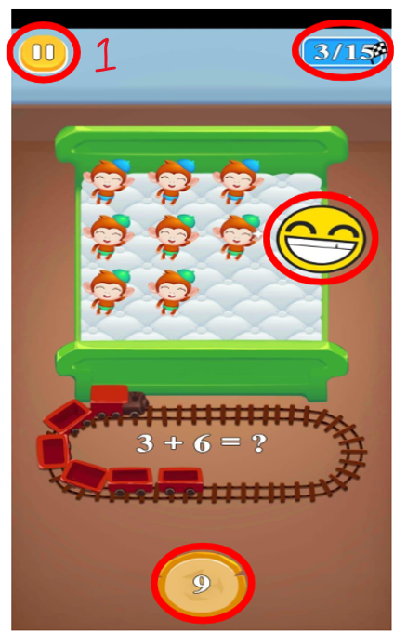

2.1 **InvokeGamePauseButton**

2.1.1 When clicked an audio event is played

2.1.2 The “Pause Menu” scene is invoked

* When answered correctly, there is a happy emoji shown
* The button containing the correct answer on the bottom remains
* The score increases by 1

1. **Game Slide - Incorrect**

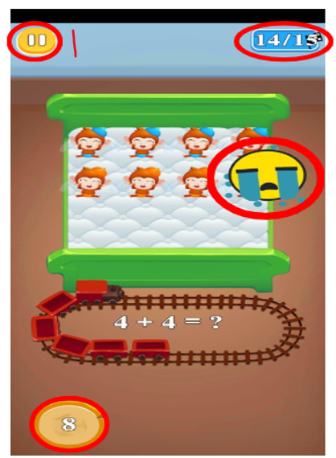

3.1 **InvokeGamePauseButton**

3.1.1 When clicked an audio event is played

3.1.2 The “Pause Menu” scene function is invoked

* When we answer incorrectly, we can notice a crying emoji
* When scored incorrectly, the score stays the same as the previous round
* The correct answer is shown in the bottom